Project Executable Files

Date | 15 July 2026
Team ID | SWTID-2026-2062
Project Name | Credit card Approval Prediction
Maximum Marks | 3 Marks

Project Executable Files
This section requires submission of all executable and deployable files for your project. Ensure all files are properly organized, named, and uploaded to the specified submission platform. The evaluator must be able to run or deploy your solution using the provided files and instructions.

Step 1: Submission Checklist

S.No | Item to Submit | Submitted(Yes/ No / NA)
1 | Complete source code (all files and folders) | YES
2 | README / Setup Guide (instructions to run the project) | YES
3 | requirements.txt / package.json / dependency file | YES
4 | Database schema / seed files (if applicable) | YES
5 | Environment configuration file  (.env.example or similar) | YES
6 | Deployed application URL (if hosted) | YES
7 | APK / Executable binary (if  applicable for mobile/desktop apps) | YES
8 | Dockerfile / Containerization config (if applicable) | YES
9 | Test files and test results | YES
10 | Demo video or walkthrough (if required) | YES

Step 2: File / Folder Structure
Provide an overview of your project's file and folder structure below:

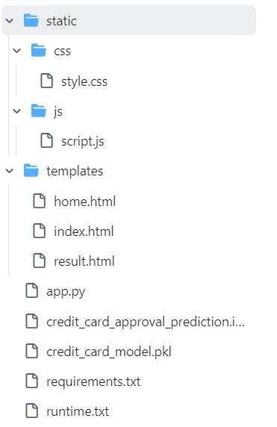

Step 3: Deployment / Access Details

Field | Details
Hosted / Deployed URL | https://smartbridge-credit-card-approval.onrender.com/
Login Credentials  (Demo) | NA
Platform / Hosting  Provider | Render
Repository Link | https://github.com/sarvani-6769/smartBridge_credit_card_ap proval_prediction/tree/main
Demo Video Link | https://youtu.be/0n1sn6Xfv1s

Step 4: Run Instructions
Provide clear, step-by-step instructions for the evaluator to run your project locally:-
Prerequisites
- Python 3.11.8
- pip (Python Package Manager)
- Git (optional, for cloning the repository)
Step 1: Clone the Repository
git clone https://github.com/sarvani-6769/smartBridge_credit_card_approval_prediction.git Step 2: Navigate to the Project Folder cd smartBridge_credit_card_approval_prediction
Step 3: (Optional) Create a Virtual Environment

Windows
python -m venv venv venv\Scripts\activate

Linux/macOS
python3 -m venv venv source venv/bin/activate
Step 4: Install Required Dependencies pip install -r requirements.txt
Step 5: Verify Required Files
Ensure the following files are present in the project directory:
- app.py
- credit_card_model.pkl
- requirements.txt
- templates/
- static/
Step 6: Run the Flask Application python app.py
Step 7: Open the Application
Open your web browser and visit: http://127.0.0.1:5000/
Step 8: Test the Application
- Click Predict on the home page.
- Enter the applicant details in the form.
- Click Predict Credit Approval.
- View the prediction result (Approved or Rejected) on the result page.

Step 5: Known Issues / Limitations
S.No | Known Issue / Limitation | Workaround / Status
1 | Model accuracy may be affected for applicants whose data differs significantly from the training dataset. | Future enhancement: Retrain the model with a larger and more diverse dataset.
2 | The application predicts approval based only on the features available in the dataset and does not consider real-time financial information (e.g., credit score, bank transactions). | Can be enhanced by  integrating external credit bureau or banking APIs in future versions.
3 | The application currently supports prediction for a single applicant at a time. | Future enhancement: Add bulk prediction using CSV file upload.

